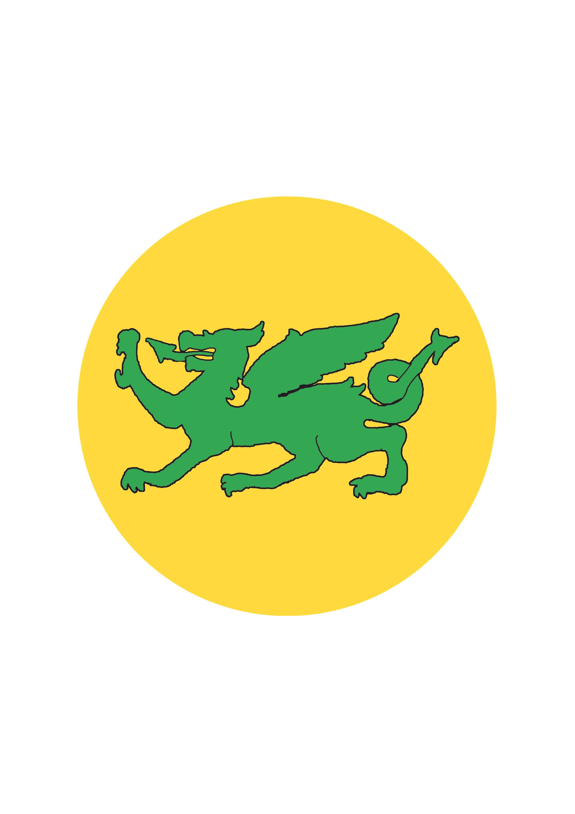
Colgate Primary School Art Learning Overview
 | EYFS | KS1 |  |  | Lower KS2 |  |  | Upper KS2
Thread |  | Year 1 Apple | Year 1 Maple | Year 2 | Year 3 | Year 4 Oak | Year 4 Cedar | Year 5 | Year 6
Developing Ideas  (through the use of sketchbooks from Year 1) | Look and talk about what they have produced, describing simple techniques and media used. | Record simple media explorations.  Investigate textures by describing, naming, rubbing, copying. | Record simple media explorations.  Begin to understand how colours can link to mood and feelings in art.  Investigate textures by describing, naming, rubbing, copying. | Plan and develop simple ideas.  Build information on colour mixing, the colour wheel and colour spectrums.  Collect textures and patterns to inform other work.  Express links between colour and emotion.  Use line and tone in different media to consider shape, shade, pattern and texture. | Record explorations and try out ideas, plan colours and plan and collect source material for future works.  Identify interesting aspects of objects as a starting point for work.  Express feelings about a subject.  Make notes about techniques used by artists.  Annotate ideas for improving their work by keeping notes. | Plan, try out ideas, plan colours and collect source material for future works.  Express likes and dislikes through annotations.  Use complimentary and contrasting colours for effect. | Plan, try out ideas, plan colours and collect source material for future works.  Adapt and improve original ideas.  Keep notes to indicate their intentions/ purpose of a piece of work.  Use complimentary and contrasting colours for effect. | Plan, try out ideas, plan colours and collect source material for future works.  Adapt work as and when necessary and explain why.  Keep notes which consider how a piece of work may be developed further. | Plan and collect source material.  Annotate work.  Consider the use of colour for mood and atmosphere.
Art through technology | Begin to use a simple computer paint program to create a picture. | Take a self-portrait or photograph.  Use a simple computer paint program to create a picture. | Take a self-portrait or photograph.  Use a simple computer paint program to create a picture. | Understand how to use ‘zoom’ to show an object in detail e.g. use a viewfinder to focus on a specific part of an artefact before drawing it.  Use a computer paint program to create and edit a picture. Use a variety of tools e.g. fill, erase etc. | Use printed images taken with a digital camera and combine them with other media.  Use ICT to create a piece of work that includes their own work and that of others (e.g. using the internet).  Take photographs and explain their creative vision. | Create a piece of art which includes integrating a digital image that they have taken.  Combine graphics and text. | Take a photo from an unusual or thought-provoking viewpoint.  Combine graphics and text. | Scan an image or take digital photographs and use software to alter them and create work with meaning.  Compose a photo with thought for textural qualities, light and shade. | Have opportunity to explore modern and traditional artists using ICT and other resources.  Combine a selection of images using digital technology, considering colour, size and rotation.
Drawing | Enjoy using tools, fingers, hands, chalk, pens and pencils.  Begin to control a range of media.  Produce lines of different thickness and tone using a pencil.  Start to produce different patterns and textures. | Experiment with a variety of media; pencils, crayons, pastels, felt tips, charcoal, pen and chalk.  Control the types of marks made with the range of media.  Develop a range of tone using a pencil and use a variety of drawing techniques such as hatching, scribbling, stippling and blending to create light/dark lines. | Experiment with a variety of media; pencils, crayons, pastels, felt tips, charcoal, pen and chalk.  Control the types of marks made with the range of media.  Develop a range of tone using a pencil and use a variety of drawing techniques such as hatching, scribbling, stippling and blending to create light/dark lines. | Continue to investigate tone by drawing light/dark lines, light/dark patterns, light/dark shapes using a pencil.  Draw lines/marks from observations.  Demonstrate control over the types of marks made with a range of media such as crayons, pastels, felt tips, charcoal, pen, chalk.  Understand tone through the use of different grades of pencils (HB, 2B, 4B) | Develop intricate patterns/marks with a variety of media.  Demonstrate experience in different grades of pencil and other implements to draw different forms and shapes.  Begin to indicate facial expressions in drawings.  Begin to show consideration in the choice of pencil grade they use. | Develop intricate patterns using different grades of pencil and other implements to create lines and marks.  Begin to show awareness of representing texture through the choice of marks and lines made.  Begin to use media and techniques (line, tone, colour) to show representation of movement in figures and forms. | Experiment with different grades of pencil/other implements to achieve variations in tone.  Develop further drawings featuring the third dimension/ perspective.  Further develop drawing a range of tones and lines using a pencil.  Use a range of techniques and begin to understand why they best suit.  Attempt to show reflections in a drawing.  Begin to use media and techniques (line, tone, colour) to show representation of movement in figures and forms. | Develop a key element of their work: line, tone, pattern, texture.  Use different techniques for different purposes i.e., shading, hatching.  Start to develop their own style using tonal contrast and mixed media.  Develop further simple perspective in their work using a single focal point and horizon.  Begin to develop an awareness of composition, scale and proportion.  Work from a variety of sources including observation, photographs and digital images.  Develop close observation skills using a variety of viewfinders. | Develop their own style of drawing. This style may be through the development of: line, tone, pattern, texture.  Use different techniques for different purposes i.e. shading, hatching, understanding which works well and why.  Develop their own style using tonal contrast and mixed media.  Develop further simple perspective in their work using a single focal point and horizon.  Develop an awareness of composition, scale and proportion.
Painting | Enjoy using a variety of tools including different size brushes and tools e.g., sponge brushes, fingers, twigs.  Recognise and name the primary colours being used.  Mix and match colours to different objects.  Explore working with paint on different surfaces. | Experiment with paint using a range of tools, e.g., different brush sizes, hands and feet.  Explore techniques e.g. lightening and darkening paint without the use of black/white.  Name the primary colours and start to mix a range of secondary colours, moving towards predicting resulting colours. | Experiment with paint using a range of tools, e.g., different brush sizes, hands, feet, rollers and pads.  Explore techniques such as lightening and darkening paint without the use of black or white.  Name the primary colours and start to mix a range of secondary colours, moving towards predicting resulting colours. | Explore a range of painting techniques e.g, layering, mixing media, and adding texture.  Make tints using white and tones by adding black to make darker and lighter shades.  Build confidence in mixing colour shades and tones.  Understand the colour wheel and colour spectrums.  Be able to mix all the secondary colours using primary colours confidently.  Use a suitable brush to produce marks appropriate to work e.g. small brush for small marks. | Use a range of brushes to show increasing control over the types of marks made. Experiment with different effects and textures including blocking in colour, washes, thickened paint creating textual effects.  Use light and dark within painting and begin to explore complimentary colours.  Create a background using a wash. | Start to develop a painting from a drawing.  Use light and dark within painting and show understanding of complimentary colours.  Mix colours, shades and tones with increasing confidence. | Control the types of marks made and experiment with different effects and textures e.g. blocking in colour, washes, thickened paint creating textual effects.  Use light and dark within painting. Show understanding of complimentary colours.  Mix colours, shades and tones with increasing confidence.  Work in the style of a selected artist (not copying). | Confidently control the types of marks made and experiment with different effects and textures including blocking in colour, washes, thickened paint creating textual effects.  Mix and match colours to create atmosphere and light effects.  Mix colour, shades and tones with confidence building on previous knowledge.  Start to develop their own style using tonal contrast and mixed media. | Work in a sustained and independent way to develop their own style of painting. This style may be through the development of: colour, tone and shade.  Purposely control the types of marks made and experiment with different effects and textures including blocking in colour, washes, thickened paint creating textual effects.  Mix colour, shades and tones with confidence building on previous knowledge.  Understand what works well in their work and why.
3-D | Enjoy using a variety of malleable media such as clay, papier mache, salt dough. Impress and apply simple decoration.  Cut shapes using scissors and other modelling tools.  Build a construction/  sculpture using a variety of objects e.g., recycled, natural and manmade materials. | Experiment in a variety of malleable media such as clay, papier-mache, salt dough and Modroc.  Shape and model materials for a purpose (e.g., a pot, tile) from observation and imagination.  Continue to manipulate malleable materials in a variety of ways including rolling, pinching, kneading.  Impress and apply simple decoration techniques, including painting. | Experiment in a variety of malleable media such as clay, papier-mache, salt dough and Modroc.  Shape and model materials for a purpose (e.g., a pot, tile) from observation and imagination.  Continue to manipulate malleable materials in a variety of ways including rolling, pinching, kneading.  Impress and apply simple decoration techniques, including painting. | Use clay, Modroc or other malleable material to create an imaginary or realistic form e.g., clay pot, figure, structure  Explore carving as a form of 3D art. | Begin to show an awareness of objects having a third dimension and perspective.  Learn to secure work to continue at a later date.  Join two parts successfully.  Construct a simple base for extending and modelling other shapes.  Produce more intricate surface patterns/textures and use when appropriate.  Produce larger ware using pinch/slab/coil techniques. | Secure work to continue at a later date.  Make a slip to join to pieces of clay.  Decorate, coil and produce marquettes confidently when necessary.  Model over an armature: newspaper frame for Modroc.  Adapt work as and when necessary and explain why.  Gain more confidence in carving as a form of 3D art. | Secure work to continue at a later date.  Make a slip to join to pieces of clay.  Use recycled, natural and manmade materials to create sculptures.  Adapt work as and when necessary and explain why.  Show awareness of the effect of time upon sculptures. | Show experience in combining pinch, slabbing and coiling to produce end pieces.  Develop understanding of different ways of finishing work: glaze, paint, polish.  Gain experience in modelling over an armature: newspaper frame for Modroc.  Use recycled, natural and manmade materials to create sculptures, confidently and successfully joining.  Show increasing confidence to carve a simple form. | Model and develop work through a combination of pinch, slab and coil.  Work around armatures or over constructed foundations.  Demonstrate experience in the understanding of different ways of finishing work: glaze, paint, polish.  Demonstrate experience in relief and freestanding work using a range of media.  Recognise sculptural forms in the environment e.g. furniture, buildings  Confidently carve a simple form.
Printing | Enjoy taking rubbings: leaf, brick, coin.  Make simple pictures by printing from objects.  Develop simple patterns by using objects.  Enjoy using stencils to create a picture. | Explore printing simple pictures with a range of hard and soft materials e.g., cork, pen barrels, sponge.  Experience impressed printing e.g., printing from objects.  Begin to identify forms of printing: books, posters, pictures, fabrics.  Use printmaking to create a repeating pattern. | Explore printing simple pictures with a range of hard and soft materials e.g., cork, pen barrels, sponge.  Experience impressed printing e.g., printing from objects.  Begin to identify forms of printing: books, posters, pictures, fabrics.  Use printmaking to create a repeating pattern. | Continue to explore printing simple pictures with a range of hard and soft materials e.g., cork, pen barrels, sponge.  Demonstrate experience at impressed printing: drawing into ink, printing from objects.  Use equipment and media correctly and be able to produce a clean, printed image.  Make simple marks on rollers and printing palettes.  Take simple prints e.g. mono printing.  Experiment with overprinting motifs and colour. | Print simple pictures using different printing techniques.  Continue to explore both mono-printing and relief printing.  Demonstrate experience in 3 colour printing. | Increase awareness of mono and relief printing.  Demonstrate experience in fabric painting.  Expand experience in 3 colour printing. | Continue to experience combining prints taken from different objects to produce an end piece.  Create repeating patterns. | Continue to gain experience in overlaying colours.  Start to overlay prints with other media.  Use print as a starting point to embroidery. Show experience in a range of mono print techniques. | Demonstrate experience in a range of printmaking techniques.  Describe techniques and processes.  Adapt their work according to their views and describe how they might develop it further.  Develop their own style using tonal contrast and mixed media.
Responding to art | Look and talk about what they have produced, describing simple techniques and media used. | Look and talk about their own work and that of other artists.  Talk about the techniques they have used.  Share their likes and dislikes.  Describe the similarities and differences between their work and the work of others.  Begin to respond to art from other cultures and other periods of time. | Look and talk about their own work and that of other artists.  Talk about the techniques they have used.  Share their likes and dislikes.  Describe the similarities and differences between their work and the work of others  Begin to respond to art from other cultures and other periods of time. | Explore the work of a range of artists, craft makers and designers.  Begin to describe the similarities and differences between different practices and make links to their own work.  Express thoughts and feelings about a piece of art and say how it makes them feel.  Explain the successes and challenges in a piece of art created.  Identify changes they might make or how their work could be developed further.  Begin to respond to art from other cultures and other periods of time. | Continue to explore the work of a range of artists, craft makers and designers.  Describe the similarities and differences between different practices and make links to their own work.  Discuss own and others work, expressing thoughts and feelings, using knowledge and understanding of artists and techniques.  Respond to art from other cultures and other periods of time. | Discuss and review own and others’ work, expressing thoughts and feelings, and identify modifications/ changes and see how they can be developed further.  Begin to explore a range of great artists, architects and designers in history. | Discuss and review own and others’ work, expressing thoughts and feelings, and identify modifications/ changes and see how they can be developed further.  Begin to explore a range of great artists, architects and designers in history. | Recognise the art of key artists and begin to place them in key movements or historical events.  Discuss and review own and others’ work, expressing thoughts and feelings, and identify modifications/ changes and see how they can be developed further.  Identify artists who have worked in a similar way to their own work.  Explore a range of great artists, architects and designers in history.  Compare different styles and approaches. | Discuss and review own and others’ work, expressing thoughts and feelings, explaining their views.  Identify artists who have worked in a similar way to their own work.  Explore a range of great artists, architects and designers in history.

