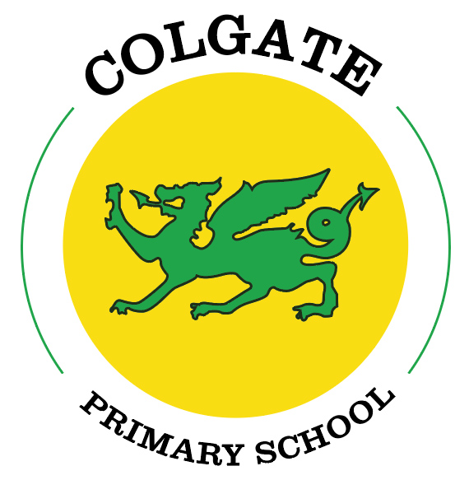

Colgate Primary School
Physical Education Policy
2023

OUR VISION: Working together to be our best

Approved by: | Curriculum and Progress Committee | Date:
Last reviewed on: November 2023
Next review due by: November 2025

Contents
1. Aims
2. Statutory requirements
3. Policy development
4. Definition
5. Delivery of Physical Education
6. Roles and responsibilities
7. Health and Safety
8. Training
9. Monitoring arrangements
10. Appendix

1. Aims
The aims of our physical education curriculum at Colgate Primary School are to:
- Promote physical activity and promote healthy and active lifestyles.
- Encourage pupils to be physically active for sustained periods of time.
- Ensure pupils are given opportunities to engage in competitive sports and activities.
- Develop our children’s competence to excel in a broad range of physical activities.
- Develop positive attitudes to health, fitness and physical activity and understand the positive impact it has on mental wellbeing.
- To develop an enjoyment of the outside world.
- To ensure safe practice when taking part in sports activities.

2. Statutory requirements
Physical Education (PE) is a compulsory subject as outlined in the National Curriculum and requires all children to participate fully in Physical Education lessons. As suggested in the National Curriculum, every child is offered a minimum of 2 hours of high quality PE a week. All children will learn and participate in the areas outlined in the curriculum map for PE. This includes swimming lessons in Oak Class, as all children are required to confidently swim 25m by the time they leave primary school. The National Curriculum for PE can be found in appendix one.

3. Policy development
This policy has been developed in consultation with staff, pupils and parents through the school newsletter. The consultation and policy development process involved the following steps:
- Review – the Physical Education coordinator pulled together all relevant information including relevant national and local guidance

- Staff consultation – all school staff were given the opportunity to look at the policy and make recommendations

- Parent/carer consultation – parents and carers are invited to raise questions about the policy

- Ratification – once amendments were made, the policy was shared with governors and ratified

4. Definition
Physical Education (PE) contributes to the overall education of all children by helping them to lead healthy and happy lives through engaging in purposeful and high-quality activity. It promotes active and healthy lifestyles, physical skills, physical development and knowledge of the body in action. The subjects ensures children develop the skills to help manage their own mental wellbeing and health. PE enables children to learn confidence, perseverance, team spirit, positive competitiveness and organisation. PE is an integral part of school practices allowing all children in the school to gain a sense of achievement and develop positive attitudes towards themselves and others.

5. Delivery of PE
PE lessons are taught in a variety of ways, all children will have one lesson a week with a sports coach and the other with their class teacher, totalling two hours per week.
We use a variety of teaching styles, our principal aim is to develop the children’s knowledge, skills and understanding. We do this through a mixture of whole-class teaching and individual/group activities. During plenaries and mini-plenaries, teachers highlight good examples of individual performance as models for the other children. We encourage the children to evaluate their own work as well as the work of other children using the agreed success criteria. Within lessons we give the children the opportunity both to collaborate and to compete with each other, and they have the opportunity to use a wide range of resources. We provide suitable learning opportunities for all children, regardless of their physical ability by matching the challenge of the task to the ability of the child. We achieve this through a range of strategies including by task or by outcome.
At Colgate Primary School, we cover a range of sports with our PE curriculum designed with all children in mind. Through adaptive teaching, we ensure all children can access the learning content and feel success in PE. For example, some children find the idea of not winning a game challenging, for these children the end goal/objective of the lesson is adapted. As part of our PE curriculum we have an inclusive sports unit, this includes a range of sports such as blindfold cricket, wheelchair basketball, boccia and goal ball.

The children will also experience five woodland activity sessions an academic year, take part in at least one sports day per year and experience sports activities in the local community.

6. Roles and responsibilities
6.1 The governing board
The governing board will approve the PE policy, and hold the headteacher to account for its implementation.
6.2 The Headteacher
The headteacher is responsible for ensuring that PE is taught consistently across the school, and for managing requests to withdraw pupils from PE.
6.3 Staff
Staff are responsible for:
- Delivering PE in a safe way
- Modelling positive attitudes to PE
- Monitoring progress
- Responding to the needs of individual pupils
Staff who may have concerns about teaching PE are encouraged to discuss this with the headteacher. Class teachers and sports coaches are responsible for delivering PE lessons at Colgate.
6.4 Pupils
All pupils are expected to engage fully with PE Lessons; children are responsible for bringing in their PE kits.

7. Health and Safety
Health and good safe practice is always emphasised in each environment, including the handling of equipment. Large equipment is inspected annually by an outside agency. Appropriate clothing is essential and children’s attire is checked by teachers prior to undertaking PE activities.
7.1 PE Kit
Children are encouraged to wear appropriate PE clothing. Shorts/jogging bottoms, t-shirts and sensible footwear for outdoor activities are recommended. Pupils are encouraged and regularly reminded to bring their P.E kits into school. The PE kit consisting of a yellow top(with or without the school logo) with plain blue, black or green shorts/leggings. Teachers send polite reminder slips home to remind parents of children who have failed to wear PE kit. Children with no PE kit will still take part in the lesson. Children are bare-footed for gymnastics/dance lessons, though they must bring their shoes to the lesson and leave them at the side in case of a fire emergency.
7.2 Jewellery and Hair
Wearing jewellery is not allowed at Colgate Primary School. Children must not wear any kind of jewellery in PE lessons, including watches. Pupils with medium/long hair are reminded to tie it up securely. Earrings need to be taken out or covered with tape.
7.3 Weather
It is encouraged that outdoor PE lessons take place in all seasons and in as many weather conditions as feasible. Children are encouraged to wear clothing in line with the season and weather conditions, maximising access to all lessons.
7.4 Hygiene
Pupils are taught about the body changes that occur when they exercise along with recognition of the short and long term effects of exercise on the body. Aspects of hygiene are addressed in upper KS2, including regularly taking their PE kit home to wash.
7.5 Staff dress
It is important that staff should consider their own and their pupils' safety with regard to their own personal clothing, footwear and jewellery when involved in the teaching of any PE activity.

7.6 Risk Assessments
Risk assessments for woodland activities and swimming are undertaken by staff and uploaded to evolve. These are carried out by the EVC coordinator and year three-class teacher.

8. Training
Staff are trained on the delivery of PE through observations of the sports coach teaching, alongside additional CPD opportunities.

9. Monitoring arrangements
The delivery of PE is monitored by Rebecca Winn, Headteacher through:
Staff meetings
Focused learning walks
Pupils’ development in PE is monitored by class teachers as part of our internal assessment systems. Photos and videos of the children’s learning is uploaded to seesaw.
This policy will be reviewed by Rebecca Winn biannually. At every review, the policy will be approved by the Curriculum and Progress committee.

10. Appendix One
Physical education programmes of study: key stages 1 and 2 - National curriculum in England
Purpose of study
A high-quality physical education curriculum inspires all pupils to succeed and excel in competitive sport and other physically-demanding activities. It should provide opportunities for pupils to become physically confident in a way which supports their health and fitness. Opportunities to compete in sport and other activities build character and help to embed values such as fairness and respect.
Aims
The national curriculum for physical education aims to ensure that all pupils:
▪ develop competence to excel in a broad range of physical activities
▪ are physically active for sustained periods of time
▪ engage in competitive sports and activities
▪ lead healthy, active lives.
Attainment targets
By the end of each key stage, pupils are expected to know, apply and understand the matters, skills and processes specified in the relevant programme of study. Schools are not required by law to teach the example content in [square brackets].
Subject content
Key stage 1
Pupils should develop fundamental movement skills, become increasingly competent and confident and access a broad range of opportunities to extend their agility, balance and coordination, individually and with others. They should be able to engage in competitive (both against self and against others) and co-operative physical activities, in a range of increasingly challenging situations.
Pupils should be taught to:
▪ master basic movements including running, jumping, throwing and catching, as well as developing balance, agility and co-ordination, and begin to apply these in a range of activities
▪ participate in team games, developing simple tactics for attacking and defending
▪ perform dances using simple movement patterns.
Key stage 2
Pupils should continue to apply and develop a broader range of skills, learning how to use them in different ways and to link them to make actions and sequences of movement. They should enjoy communicating, collaborating and competing with each other. They should develop an understanding of how to improve in different physical activities and sports and learn how to evaluate and recognise their own success.
Pupils should be taught to:
▪ use running, jumping, throwing and catching in isolation and in combination
▪ play competitive games, modified where appropriate [for example, badminton, basketball, cricket, football, hockey, netball, rounders and tennis], and apply basic principles suitable for attacking and defending
▪ develop flexibility, strength, technique, control and balance [for example, through athletics and gymnastics]
▪ perform dances using a range of movement patterns
▪ take part in outdoor and adventurous activity challenges both individually and within a
team
▪ compare their performances with previous ones and demonstrate improvement to achieve their personal best.
Swimming and water safety
All schools must provide swimming instruction either in key stage 1 or key stage 2.
In particular, pupils should be taught to:
▪ swim competently, confidently and proficiently over a distance of at least 25 metres
▪ use a range of strokes effectively [for example, front crawl, backstroke and breaststroke]
▪ perform safe self-rescue in different water-based situations.

HEAD TEACHER: R.Winn

CHAIR CURRICULUM AND PROGRESS COMMITTEE: Mrs J. Watson

DATE: November 2023 REVIEW DATE: November 2025

