Can you drink the sea?
Beside the Seaside!
Apple Class – Summer Term 2023

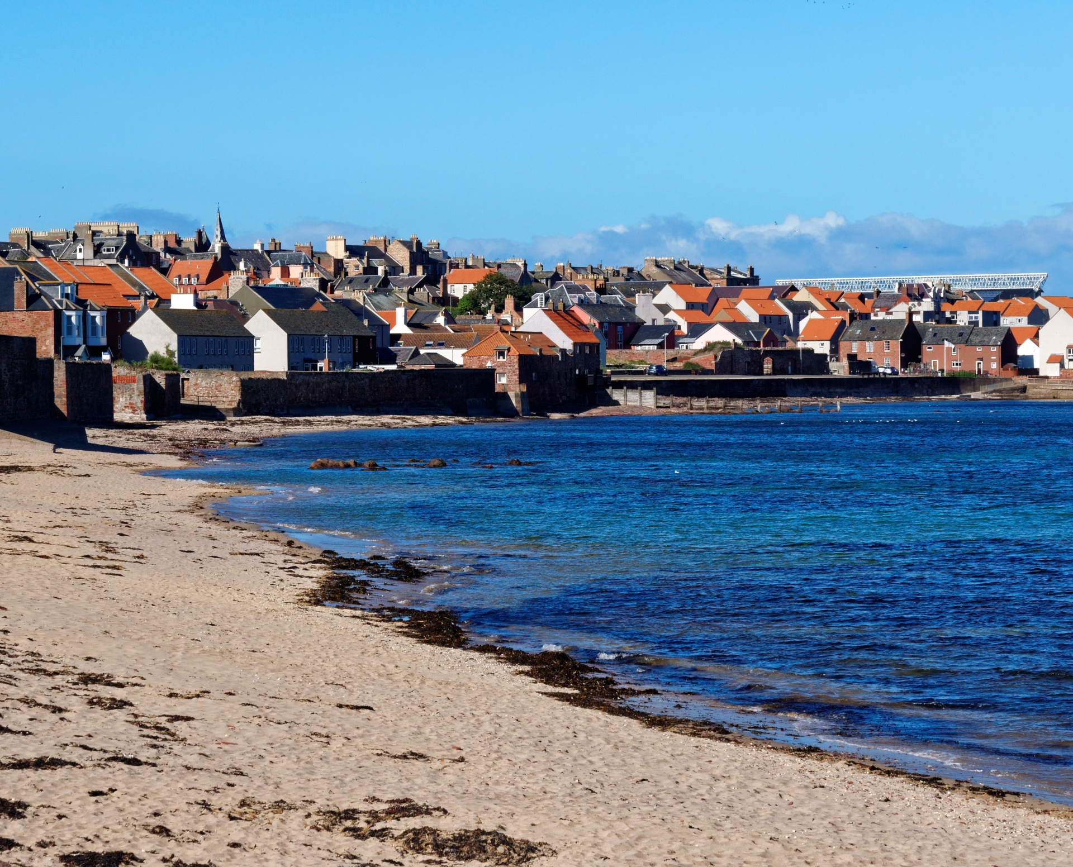
Dear Families,
We hope that you have all had a restful Easter break.
Here is an outline of our learning for the Summer Term. The learning for Year One children will be linked to the National Curriculum and for Reception, it will be linked to the seven areas of the Early Years Curriculum. However, although the Reception children will join in with some of the topic learning, they will spend the majority of their time pursuing their own interests whilst learning through play. Reception will continue to have Phonics, Maths, English, PSHE and PE lessons.

Monday and Friday- we will be changing reading books so please ensure books are in book bags
Friday- we will be issuing new Apple Class library books so please return them if you would like a new one

Please ensure PE kits are in school at all times. Our PE days will be Monday and Wednesday but there are occasions where we may need to swap our days around.

Thank you for your support and please do not hesitate to speak to a member of staff or message us on Seesaw if you have any concerns or questions. We are always happy to help!
Kind Regards
Mrs Champion, Mrs Burton, Mrs Glassford and Mrs Urganci

PSHE and RSE  Online relationships  Internet safety  Economic well-being  First aid  Our Bodies |  |  | Useful websites/apps:  - White Rose 1 Minute Maths app (Reception and Year 1)  - Hit the Button app (number facts for Year 1)  - iLearn2 website for Computing skills- codes to log into the activities will be shared on Seesaw  - Dance Mat typing- typing skills for Year 1  - Busy Things website for Reception- password and login details have been shared via Seesaw
English  Class texts for Reception and Year 1:  -stories and non fiction linked to the seaside and plants  Writing to Entertain:  -retelling stories  -character descriptions  Writing to Inform:  -writing a postcard  -writing instructions  -writing a recount | Maths  Reception:  Numbers 1-10 and beyond  Pattern and shape  Addition  Subtraction  Doubling  Sharing and grouping  Odd and even  Year 1:  Addition and Subtraction to 20  Place Value to 50 and 100  Fractions  Multiplication and Division  Time | Science  Revisit Animals including humans  Plants  Seasonal change | History  Significant People:  -King Charles  Seaside past and present | Geography  Place and locational knowledge  Human and physical Geography-  Describing some of the human and physical features of the seaside.  Observe and describe daily weather patterns.
 |  | PE  Invasion Games  Multi-Skills  Sports Day practice | Art  Sea creature sculptures using clay  Revisit Sketching (shells) | Computing  Revisit E-Safety for Reception and Year 1  Year 1:  Text and Images  Comic Creation  Music Creation
 |  | Music  Music Express | DT  Design and make a small bag/purse | RE  Islam:  - Prayer at home  -Hajj

