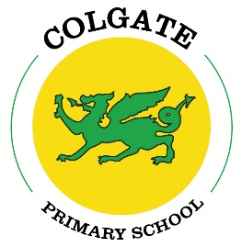

Colgate Primary School Statutory test results 2025

National outcomes in red

EYFS

Good Level of Development (GLD) = 59% 68%

Year 1 Phonics = 84% pass 80%

Year 2 Phonics = 83% pass %

KS2

Percentages in blue are our results without the children who couldn’t access the tests.

Reading: 80**%** Age Related Expectations+ (ARE) 75% 89%

30**%** Higher attainers 33%

Average scaled score = 96.25 106 106.9

Writing: 50**%** ARE+ 72% 63%

5**%** Greater Depth Standard 13%

Maths: 75% ARE+ 74%

20**%** Higher attainers 26%

Average scaled score = 90.55 105 106.5

Combined RWM: 50**%** ARE + 62% 59%

5**%** GDS 8% 6%