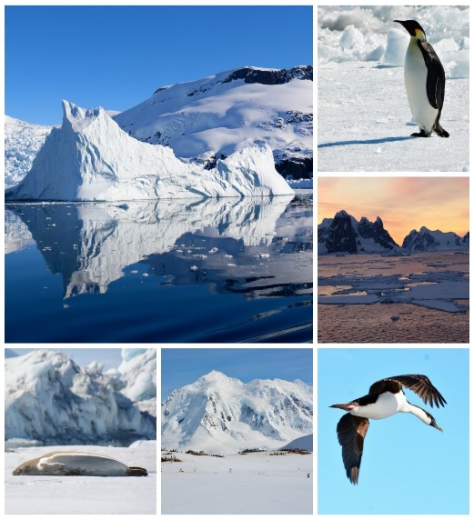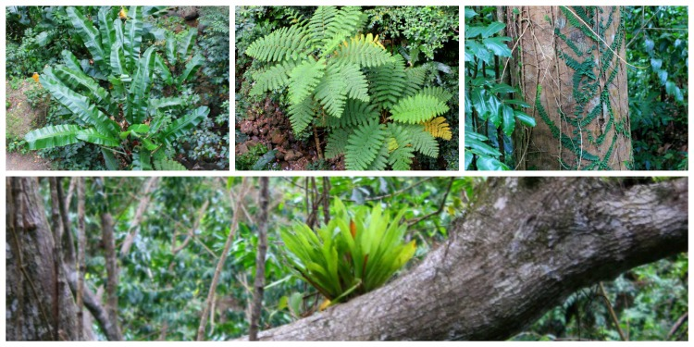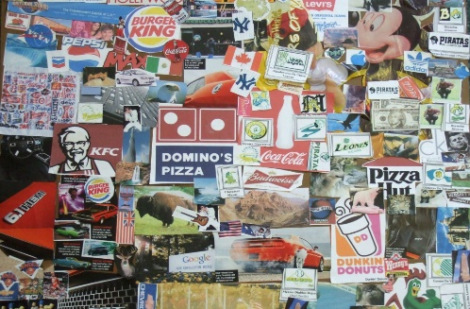

Stop deforestation /recycle more Poster

Create a poster to persuade people to stop deforestation or to recycle more. Make sure you include information as well as pictures.

Investigating a country that has a rainforest in.

Choose a country you don’t know a lot about. Create a fact file on that country and include lots of information about that rainforest.

Creating a Collage

Create a collage half with Antarctica and half with the rainforest. Use magazines, newspapers and the internet for pictures.

Write a persuasive letter.

Write a letter persuading the government they need to do more to make sure that deforestation stops taking place. Write a letter to the government persuading them we need to do more to make sure people recycle more.

Animals around the World

Choose either the rainforest or Antarctica and research the animals that live in that location. Choose animals and explain how they have adapted to their habitats.

Rainforest Maths

Create 10 multi-step word problems on life in the rainforest. You need to write an answer sheet showing each step of the problem. You will be given time to swap your problems in class. Make sure your problems involve adding, subtraction, multiplication and dividing.

Environmental Issues

What are the problems facing our planet today?

Create a poster explaining the problems our planet is facing.

Travel Agent- Maths

Your challenge is to work out how much a holiday to a country that contains a rainforest would cost.

Remember to include the price of the flight, hotel, attractions and food. Tell me who you would fly with, where you would stay and what attractions you will do.

Antarctica Maths

Create 10 multi-step word problems on life in Antarctica. You need to write an answer sheet showing each step of the problem. You will be given time to swap your problems in class.

Do you think we live in a wonderful world or a worsening world?

Present your argument to the question. Remember you can present your ideas through pictures, videos or writing.

*What a wonderful world- Antarctica and the Rainforest*

