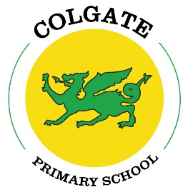

Colgate Primary School Statutory test results 2023
National outcomes in red

EYFS
Good Level of Development (GLD) = 63% 67%

Year 1 Phonics = 62% pass 79%
Year 2 Phonics = 25% pass 59%

KS1

Reading: 63% At Age Related Expectation (ARE) 68%
26% Exceeding Age Related Expectation (GDS) 19%

Writing: 63% ARE 60%
5% GDS 8%

Maths: 79% ARE 70%
26% GDS 16%

KS2

Reading: 88% ARE 73%
38% GDS 29%
Average scaled score = 107.4 105.1
Progress score 1.9 1.0

Writing: 69% ARE 72%
0% GDS 13%
Progress score -2.3 1.0

Maths: 94% ARE 73%
44% GDS 24%
Average scaled score = 107.1 104.2
Progress score 2.4 1.0

Combined RWM: 69% ARE 60%
0% GDS 8%

