Colgate Primary School
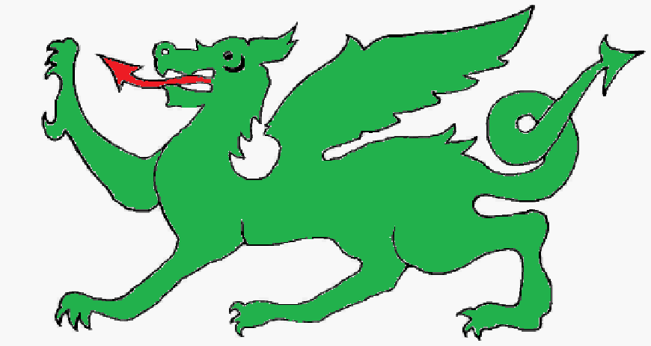

End of Year Expectations in
Literacy

This booklet is designed to help you to understand end of year expectations in Literacy.



Literacy Expectations

This booklet is designed to inform you about the end of year expectations in Literacy for each year group in line with the new national curriculum.
In order to achieve end of year expectations children are required to meet all the objectives for their year group.

End of year reporting

Below end of year expectations (working within expectations of a previous year group)
Working towards end of year expectations (working within the expectations of their year group)
Meeting end of year expectations (achieving all the expectations of their year group)
Meeting, with deeper understanding, end of year expectations (developing a deeper understanding and applying their knowledge of the expectations within their year group)

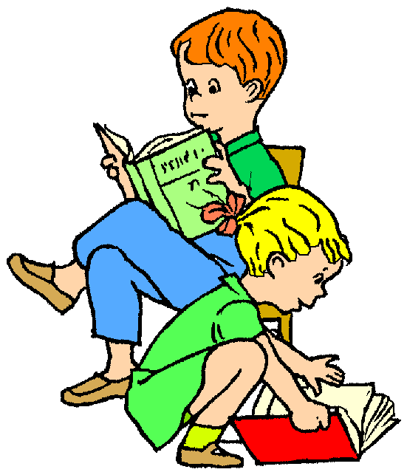

Reading:
- Children read and understand simple sentences. They use phonic knowledge to decode regular words and read them aloud accurately. They also read some common irregular words. They demonstrate an understanding when talking with others about what they have read.
Writing:
- Children use their phonic knowledge to write words in ways which match their spoken sounds. They also write some irregular common words. They write simple sentences which can be read by themselves and others. Some words are spelt correctly and others are phonetically plausible.

EYFS Literacy
End of Year Expectations

Some children may exceed the ELG (early learning goal) for these areas. They will then be working at the descriptors below:
- Reading: Children can read phonically regular words of more than one syllable as well as many irregular but high frequency words. They use phonic, semantic and syntactic knowledge to understand unfamiliar vocabulary. They can describe the main events in the simple stories they have read.
- Writing: Children can spell phonically regular words of more than one syllable as well as many irregular but high frequency words. They use key features of narrative in their own writing.

Year 1 Reading
End of Year Expectations
Year 1 will be working on the expectations highlighted in green during Autumn term 2017

Word Reading:
•I can match all 40+ graphemes to their phonemes.
•I can blend sounds in unfamiliar words.
•I can divide words into syllables.
•I can read compound words.
•I can read words with contractions and understand that the apostrophe represents the missing letters.
•I can read phonetically decodable words.
•I can read words that end with‘s, -ing, -ed, -est.
•I can read words which start with un-.
•I can add –ing, -ed and –er to verbs (where no change is needed to the root word).
•I can read words of more than one syllable that contain taught GPCs.

Comprehension:
•I can say what I like and do not like about a text.
•I can link what I have heard or read to my own experiences.
•I can retell key stories orally using narrative language.
•I can talk about the main characters within a well known story.
•I can learn some poems and rhymes by heart.
•I can use what I already know to understand texts.
•I can check that my reading makes sense and go back to correct when it doesn’t.
•I can draw inferences from the text and/or the illustrations (beginning to).
•I can make predictions about the events in the text.
•I can explain what I think a text is about.

Year 2 Reading
End of Year Expectations

Word Reading:
• I can apply knowledge of root words, prefixes and suffixes to read aloud and to understand the meaning of unfamiliar words.
• I can read further exception words, noting the unusual correspondences between spelling and sound.
• I attempt pronunciation of unfamiliar words drawing on prior knowledge of similar looking words.

Comprehension:

• I read a range of fiction, poetry, plays, and non-fiction texts.

• I can discuss the texts that I read.

• I can read aloud and independently, taking turns and listening to others.

• I can explain how non-fiction books are structured in different ways and can use them effectively.

• I can explain some of the different types of fiction books.

• I can ask relevant questions to get a better understanding of a text.

• I can predict what might happen based on details I have.

• I can draw inferences such as inferring a characters’ feelings, thoughts and motives from their actions.

• I can use a dictionary to check the meaning of unfamiliar words.

• I can identify the main point of a text.

• I can explain how structure and presentation contribute to the meaning of texts.

• I can use non-fiction texts to retrieve information.

• I can prepare poems to read aloud and to perform, showing understanding through intonation, tone, volume and action.

Statistics

and sorting the categories by quantity
▪ ask and answer questions about totalling and comparing categorical data.

Year 3 Reading
End of Year Expectations

Word Reading:
• I can apply knowledge of root words, prefixes and suffixes to read aloud and to understand the meaning of unfamiliar words.
• I can read further exception words, noting the unusual correspondences between spelling and sound.
• I attempt pronunciation of unfamiliar words drawing on prior knowledge of similar looking words.

Comprehension:
• I read a range of fiction, poetry, plays, and non-fiction texts.
• I can discuss the texts that I read.
• I can read aloud and independently, taking turns and listening to others.
• I can explain how non-fiction books are structured in different ways and can use them effectively.
• I can explain some of the different types of fiction books.
• I can ask relevant questions to get a better understanding of a text.
• I can predict what might happen based on details I have.
• I can draw inferences such as inferring a characters’ feelings, thoughts and motives from their actions.
• I can use a dictionary to check the meaning of unfamiliar words.
• I can identify the main point of a text.
• I can explain how structure and presentation contribute to the meaning of texts.
• I can use non-fiction texts to retrieve information.
• I can prepare poems to read aloud and to perform, showing understanding through intonation, tone, volume and action.

Year 4 Reading
End of Year Expectations

Word Reading:
• I can apply knowledge of root words, prefixes and suffixes to read aloud and to understand the meaning of unfamiliar words.
• I can read further exception words, noting the unusual correspondences between spelling and sound.
• I attempt pronunciation of unfamiliar words drawing on prior knowledge of similar looking words.

Comprehension:
• I know which books to select for specific purposes, especially in relation to science, geography and history learning.
• I can use a dictionary to check the meaning of unfamiliar words.
• I can discuss and record words and phrases that writers use to engage and impact on the reader.
• I can identify some of the literary conventions in different texts.
• I can identify the (simple) themes in texts.
• I can prepare poems to read aloud and to perform, showing understanding through intonation, tone, volume and action.
• I can explain the meaning of words in context.
• I can ask relevant questions to improve my understanding of a text.
• I can infer meanings and begin to justify them with evidence from the text.
• I can predict what might happen from details stated and from the information I have deduced.
• I can identify where a writer has used precise word choices fo reffect to impact on the reader.
• I can identify some text type organisational features, for example, narrative, explanation and persuasion.
• I can retrieve information from non-fiction texts.
• I can build on others’ ideas and opinions about a text in discussion.

Word Reading:
• I can apply knowledge of root words, prefixes and suffixes to read aloud and to understand the meaning of unfamiliar words.
• I can read further exception words, noting the unusual correspondences between spelling and sound.
• I attempt pronunciation of unfamiliar words drawing on prior knowledge of similar looking words.
• I can re-read and read ahead to check for meaning.

Year 5 Reading End of Year Expectations

Comprehension:
• I am familiar with and can talk about a wide range of books and text types, including myths, legends and traditional stories and books from other cultures and traditions. I can discuss the features of each.
• I can read non-fiction texts and identify the purpose, structure and grammatical features, evaluating how effective they are.
• I can identify significant ideas, events and characters; and discuss their significance.
• I can recite poems by heart, e.g. narrative verse, haiku.
• I can prepare poems and plays to read aloud and to perform, showing understanding through intonation, tone, volume and action.

Word Reading:
• I can apply knowledge of root words, prefixes and suffixes to read aloud and to understand the meaning of unfamiliar words.
• I use my combined knowledge of phonemes and word deriviations to pronounce words correctly, e.g. arachnophobia.
• I attempt the pronunciation of unfamiliar words drawing on my prior knowledge of similar looking words.
• I can read fluently, using punctuation to inform meaning.
Year 6 Reading
End of Year Expectations

Comprehension:
• I am familiar with and can talk about a wide range of books and text types, including myths, legends and traditional stories and books from other cultures and traditions. I can discuss the features of each.
• I can read books that are structured in different ways.
• I can recognise texts that contain features from more than one text type.
• I can evaluate how effectively texts are structured and presented.
• I can read non-fiction texts to help with my learning.
• I read accurately and check that I understand.
• I can recommend books to others and give reasons for my recommendation.
• I can identify themes in texts.
• I can identify and discuss the conventions in different text types.
• I can identify the key points in a text.
• I can recite a range of poems by heart, e.g. narrative verse, sonnet.
• I can prepare poems and plays to read aloud and to perform, showing understanding through intonation, tone, volume and action.

Useful Websites

Listed below are some of the many maths websites available which children could use to enhance their skills at home.

www.coolmath4kids.com/

www.woodlands-junior.kent.sch.uk/maths/

www.mathplayground.com/games.html

www.maths-games.org/

www.coolmath-games.com/

www.ictgames.com/resources.html

www.bbc.co.uk/skillswise/maths/games

www.bbc.co.uk/schools/ks1bitesize/numeracy/

www.mathszone.co.uk/

www.subtangent.com/maths/games.php

Should you wish to know more about the expectations or your child’s progress, then please arrange an appointment with their class teacher.

Colgate Primary School

