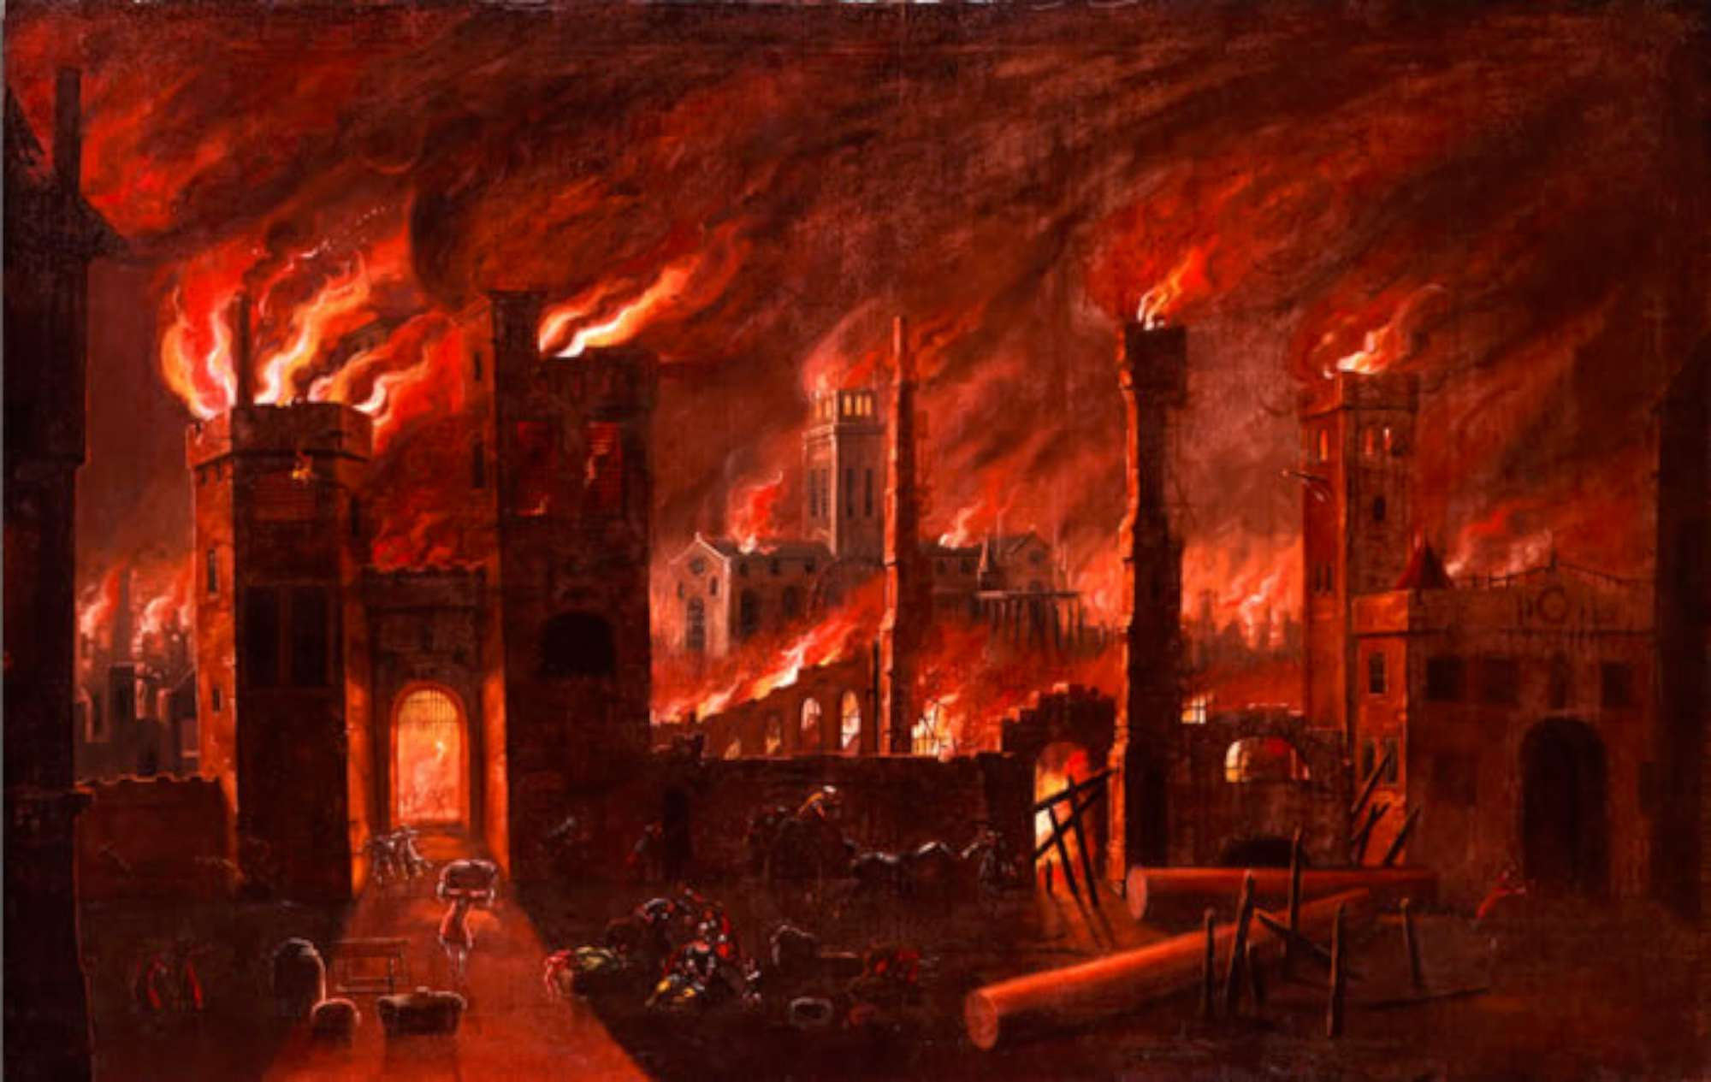 Maple Class – Spring Term 2020
Dear Parents and Carers,
Happy New Year to you all and many thanks for the Christmas cards and gifts that we received. We were very touched by your kind words and generosity. Here is an outline of what we will be learning during this term. The work in each area will be linked to the National Curriculum. This term our topic will be “Fire and Ice”. P.E will continue to be on Mondays and Wednesdays. Thank you for your continued support.
Kind Regards
Mrs Forrest and Mrs Hilder
Personal, Social  and Emotional Development  We will be thinking about ‘Money Matters.’ The class will be learning about why we have money and what it means to be able to afford something. The children will be looking at the differences between wants and needs.  Later in the term we will be learning about foods from around the world and Fair trade principles. | Communication, Language and Literacy  We will be using a variety of fiction and non-fiction books based around hot and cold concepts and ideas. They will use these books to gather information about our topic learning. The children will be looking at non fiction books and their layout such as the contents page, the glossary and the index page.  We will continue to use Song of Sound every day. Now that we know the songs, we will be providing daily opportunities to practise and apply the children’s knowledge of letter names, sounds and actions in a variety of ways.  The class will be writing with adults, in pairs and independently using the stories they read to inspire their ideas. They will develop their collaboration and co-operation skills in order to collect information about animals that live in cold or hot places.  We will be taking a closer look this term at the books children are reading at home ensuring that the books they choose match their phonic decoding ability. They should be changing their book everyday where possible. We very much welcome your comments in the reading record book so please write a short note when you have read with your child. | Mathematical Development  Year 1 will be learning to add and subtract with numbers up to 20 and place value work will be within 50.  For Year 2 much of this term’s mathematical learning will be about subtraction, fractions, multiplication and division. The class will be making equal groups both by sharing and grouping. They will learn to use their knowledge of times tables to divide by 2, 5 and10.  Topic Maths for all this term will include work on money, telling the time and measurement.
ICT
We are going to learn how to be safe online and how to search for information using the Internet. We will then use our skills to create information pages using Word. We will be using features such as borders, copying and pasting, WordArt and text boxes.
We will also improve our typing skills using BBC Dance Mat typing.
P.E

We will continue to develop our skills in Gymnastics.
We are also going to create and perform simple themed dances linked to our topic work. Later in the term the children will take part in multi-skills activities.
History and Geography  There will be a focus this term on place knowledge and the children will be using a range of maps, globes and atlases to find places around the word. They will be able to locate hot and cold places and talk about what these places are like.  The class will find out about the Great Fire of London. They will learn some of the ways in which we find out about the past such as from the diary of Samuel Pepys. | Science, DT and RE  .  We will revise our learning on Seasonal Changes before moving on to looking at Animals including humans and Living Things and their Habitats. This scientific learning will be linked to our geographical topic work.  Just before Easter the children will be looking at recipes and ingredients and making Easter Nests. In RE the children will be learning about Moses and the events of Palm Sunday leading up to the Easter events. | Music and Art  We will be learning songs and appraising different pieces of music. We will learn to say what we like and dislike when listening to new music. Our new unit is called ‘Zootime!”. This is linked to Reggae music.  The children will be producing Winter Pictures using a blowing paint technique as well as exploring colour mixing and producing fire inspired art.

