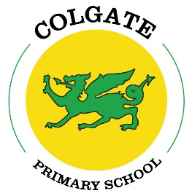

Colgate Primary School Statutory test results 2024

National outcomes in red

EYFS

Good Level of Development (GLD) = 60% 68%

Year 1 Phonics = 74% pass 80%

Year 2 Phonics = 75% pass 55%

KS2

Reading: 91**%** Age Related Expectations (ARE) 74%

32**%** Greater Depth Standard 29%

Average scaled score = 105.7 105.2

Writing: 73**%** ARE 72%

5**%** GDS 13%

Maths: 77% ARE 73%

14**%** GDS 24%

Average scaled score = 104 104.4

Combined RWM: 59**%** ARE 61%

0**%** GDS 8%