

Supporting your child with

Calculations

This booklet is designed to help you help your child to carry out addition, subtraction, multiplication and division efficiently. It shows you mental strategies that they can use and then the progression to written methods.

Understanding the Concepts

+ Understanding Addition +  - Addition can be seen as:  - combining two sets to make a total  - counting on steps along a number line  - Adding zero leaves a number unchanged  - Addition reverses subtraction  - More than two numbers can be added  - Addition can be done in any order | + Vocabulary for Addition +  more/more than  add  sum  total  altogether  plus  increase
- Understanding Subtraction -  - Subtraction can be seen as:  - Taking away  - Finding the difference  - counting on, as when working out change  - Subtracting zero leaves a number unchanged  - Subtraction reverses addition  - Subtraction cannot be done in any order | - Vocabulary for Subtraction -  take away  subtract  less than  how many are left?  difference between  minus  decrease
x Understanding Multiplication x  - Multiplication can be seen as:  - Repeated addition: 5x3 = 5+5+5  - Describing an array:  e.g. 4 x 2 as  - Multiplication can be done in any order  - Halving reverses doubling  - Multiplication reverse division  - Multiplication by one leaves a number unchanged  - Multiplication of zero results in zero | x Vocabulary for Multiplication x  double  times  multiply  multiple of  lots of  groups of  product
÷ Understanding Division ÷  - Division can be seen as:  - Sharing equally – 18 sweets shared equally between 3 people  - Grouping (repeated subtraction) – 18 sweets, how many packets of 3?  - Division cannot be done in any order  - Halving reverses doubling  - Division reverses multiplication  - Dividing a whole number by one leaves a number unchanged  - Knowing whether a remainder needs to be rounded up or down to make sense of a problem | ÷ Vocabulary for Division ÷  share  group  halve  divide  equal groups  remainder  quotient
Mental Calculation Strategies
We want children to carry out calculations in their heads whenever possible. We need to give them a repertoire of strategies so that they can be efficient and accurate. Here are some examples:

+ Addition +
- Know addition facts for all numbers to 20
- Put the larger number first | 2 + 36 = 36 + 2
- Partitioning and recombining | 55 + 37 = 55 + 30 + 7  Or 50 + 30 + 5 + 7
- Bridging through multiples of 10 | 57 + 8 = 57 + 3 + 5
- Adding 9 or 11 | 58 + 9 = 58 + 10 – 1  And 58 + 11 = 58 + 10 + 1
- Using near doubles | 38 + 35 is double 35 and 3

- Subtraction -
- Know subtraction facts corresponding to addition facts to 20
- Partitioning and recombining | 58 – 32 = 58 – 30 - 2
- Bridging through multiples of 10 | 57 – 12 = 57 – 7 - 5
- Subtracting 9 or 11 | 58 - 9 = 58 - 10 + 1  And 58 - 11 = 58 - 10 - 1
- Finding a small difference between two numbers by counting on

x Multiplication x
- Know multiplication facts to 10 x 10
- Multiply by multiples of 10 by moving the digits to the left | 26 x 10 = 260  732 x 100 = 73200
- Partition to multiply | 47 x 5 = (40 x 5) + (7 x 5)
- Multiply by using factors | 45 x 20 = 45 x 10 x 2
- Use doubling | 17 x 8 = 17 x 2 x 2 x 2
- Use closely related facts | 9 x 49 = (10 x 49) - 49

÷ Division ÷
- Know division facts corresponding to multiplication facts to 10 x 10
- Divide by multiples of 10 by moving digits to the right | 480 ÷ 10 = 48  7304 ÷ 100 = 73.04
- Use halving | 96 ÷ 4 = 96 ÷ 2 ÷ 2
- Use knowledge of table facts and place value | 560 ÷ 8 = 70

35
24
?
+ Stages in Written Addition +

1) (Year 1) Counting and adding with objects. Link to the addition number sentence.
Children to understand that addition can be done in any order.
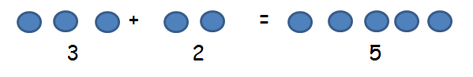

2) (Year 1) Counting on in jumps of 1 on a number line.
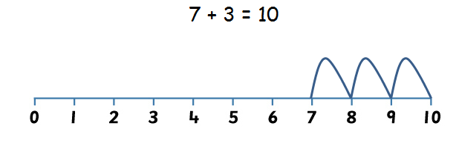

3) (Year 2) Children use base-ten apparatus and the calculation mats to add 2-digit numbers. Write calculations as a number sentence and set out in columns. Teacher to draw the bar model.
Progress through: - adding multiples of 10 e.g. 50 + 30 =
- 2-digit and a multiple of ten e.g. 54 + 20 =
- 2-digit without crossing boundaries e.g. 54 + 23 =

→ (mental methods: adding tens and ones without crossing boundaries. See mental progression booklet)

→ (mental methods: adding tens and ones with crossing boundaries. See mental progression booklet)

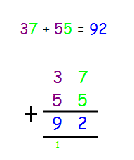
4) (Year 3) Column addition:
TO + TO (with regrouping)
Children to draw the bar model.

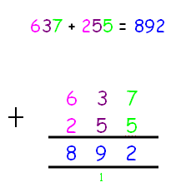
5) (Year 3) Column addition:
HTO + HTO (with regrouping)
Children to draw the bar model.

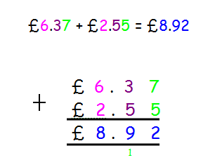
6) (Year 4) Column addition:
O.th + O.th with money
Children to draw the bar
model.

7) (Year 4) Column addition: ThHTO + ThHTO

8) (Year 5) Column addition: More than 4 digits.

9) (Year 5+) Column addition: decimals and mix of places.
E.g. 314.6 + 29.85 =
?
59
35
- Stages in Written Subtraction -

1) (Year 1) Counting and adding with objects. Link to the subtraction number sentence.
Children to understand that subtraction cannot be done in any order.
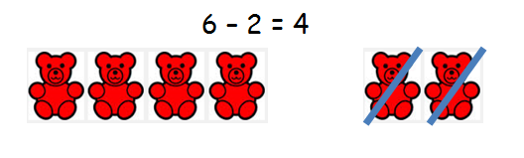

2) (Year 1) Counting back in jumps of 1 on a number line.

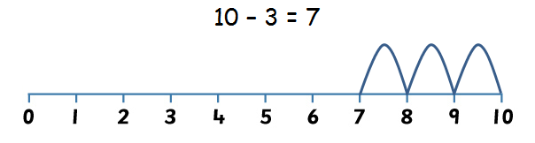

3) (Year 2) Children use base-ten apparatus and the calculation mats to subtract 2-digit numbers. Write calculations as a number sentence and set out in columns. Teacher to draw the bar model.
Progress through: - subtracting multiples of 10 e.g. 60 - 40 =
- 2-digit and a multiple of ten e.g. 64 - 40 =
- 2-digit without crossing boundaries e.g. 64 - 41 =

→ (mental methods: practise mentally subtracting ones across boundaries e.g. 32 – 5, See mental progression booklet)
→ (mental methods: using a number line to count back, first without crossing boundaries and then with. See mental progression booklet)
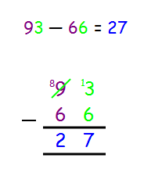
4) (Year 3) Column subtraction:
TO - TO = (with regrouping)
Children to draw the bar model.

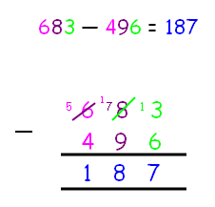
5) (Year 3) Column subtraction:
HTO - HTO = (with regrouping)
Children to draw the bar model.

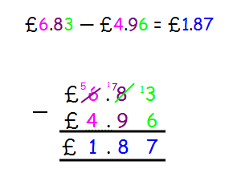
6) (Year 4) Column subtraction:
O.th - O.th with money
Children to draw the bar model.

7) (Year 4) Column subtraction: ThHTO - ThHTO

8) (Year 5) Column subtraction: More than 4 digits.

9) (Year 5+) Column subtraction: decimals and mix of places.
E.g. 314.6 - 29.85 =

5
?
5
5
5
5
x Stages in Written Multiplication x

1) (Year 1) Lots of practice solving ‘real life’ problems using apparatus.
Counting in 2s, 5s and 10s.
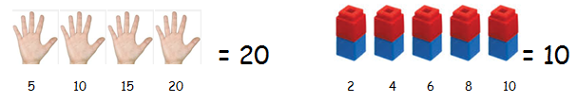

2) (Year 2) Lots of practice solving ‘real life’ problems using apparatus.
Counting in 2s, (3s), 5s and 10s.
Introduce children to the x symbol. Teacher to draw the bar model.
Relate multiplication to repeated addition.
Understand the commutative nature of multiplication.
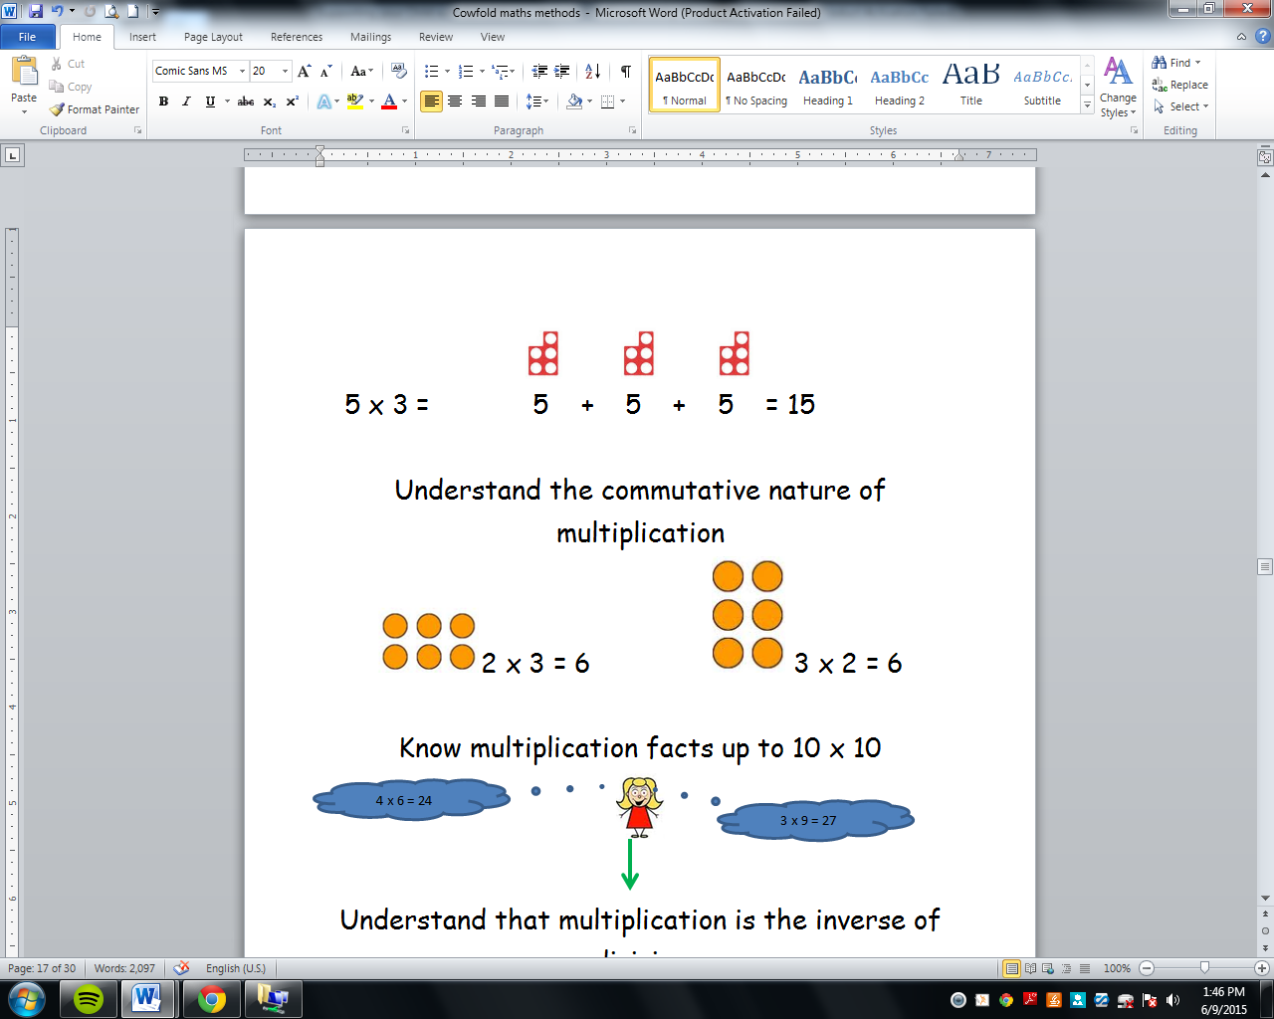
Use numicon pieces, number rods and tracks, make dot arrays with numicon pegs and boards.
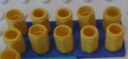

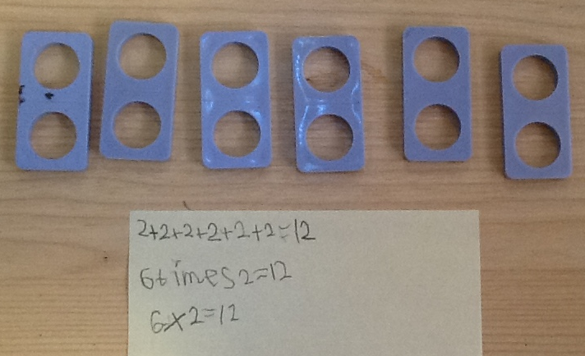
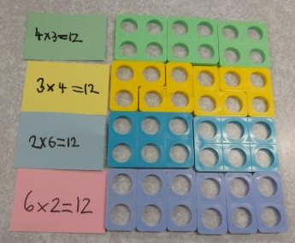

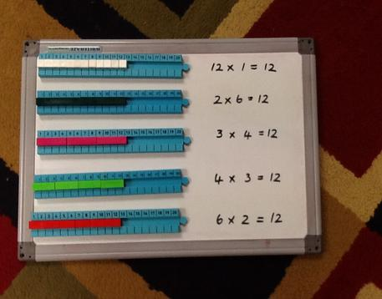

3) (Year 3) Continued practice solving ‘real life’ problems using apparatus.
Counting in 2s, 3s, 4s, 5s, 8s and 10s.
Children to be able to draw the bar model.
Relate multiplication to repeated addition.
Understand the commutative nature of multiplication.
Use numicon pieces, number rods and tracks, make dot arrays with numicon pegs and boards.

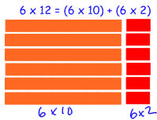
4) (Year 3) TO x O using number rods.
Children to draw the bar model.

5) (Year 3) TO x O Grid/Box method in conjunction with number rods. Boxes to represent the relative size of the number.
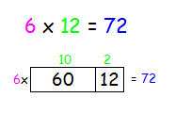
Children to draw the bar model.

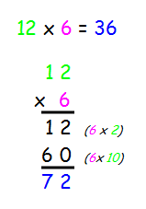
6) (Year 3) TO x O Expanded column multiplication. To be taught/seen in conjunction with the box method.
Children to draw the bar model.

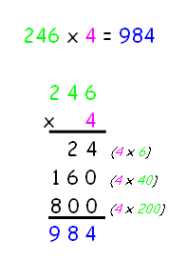
7) (Year 4) HTO x O Expanded column multiplication. To be taught/seen in conjunction with the box method.
Children to draw the bar model.

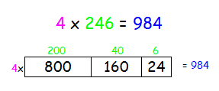

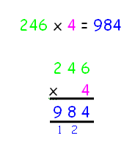
8) (Year 4) HTO x O Compact column multiplication.

9) (Year 5) ThHTO x O Compact column multiplication.

10) (Year 5) TO x TO Compact column multiplication.

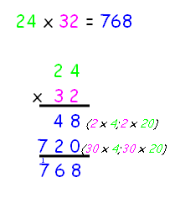
(Could use as visual aid to see what is being worked out)
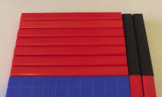

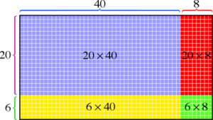

11) (Year 5) HTO x TO Compact column multiplication.

12) (Year 5) ThHTO x TO Compact column multiplication.

13) (Year 6) HTO.t x O Compact column multiplication.

14) (Year 6) TO.th x O Compact column multiplication.

15) (Year 6) O.thth x O Compact column multiplication.

?
5
25
÷ Stages in Written Division ÷

1) (Year 1) Lots of practice solving ‘real life’ problems using apparatus.
Plenty of grouping and sharing.
Using their knowledge of counting in 2s, 5s and 10s.
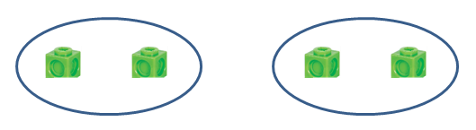

2) (Year 2) Lots of practice solving ‘real life’ problems using apparatus.
Plenty of grouping and sharing.
Using their knowledge of counting in 2s, (3s), 5s and 10s.
Introduce children to the ÷ symbol. Teacher to draw the bar model.
Understand division is the inverse of multiplication.
Use numicon pieces, number rods and tracks, make dot arrays with numicon pegs and boards.
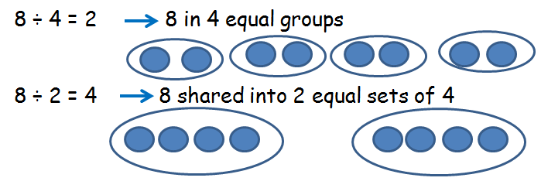
Use the language ‘How many __ in __?’.
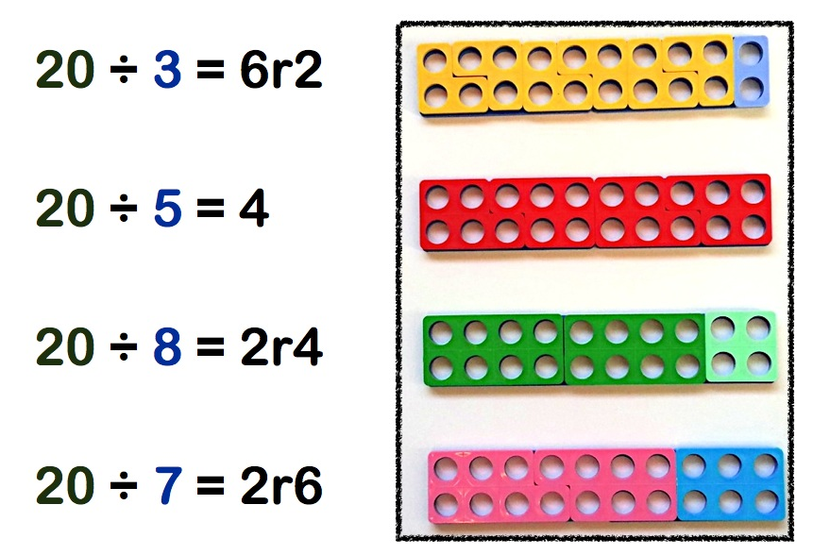
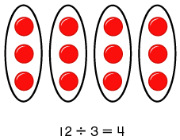

3) (Year 3) Continued practice solving ‘real life’ problems using apparatus.
Plenty of grouping and sharing.
Using their knowledge of counting in 2s, 3s, 4s, 5s, 8s and 10s.
Children to be able to draw the bar model.
Understand division is the inverse of multiplication.
Use numicon pieces, number rods and tracks, make dot arrays with numicon pegs and boards.
Use the language ‘How many __ in __?’.
Count on using a number line in conjunction with using number rods.
Interpret remainders in context.

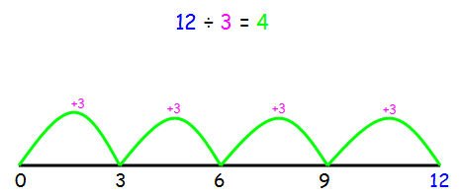

Use dot arrays (numicon pegs on boards) to begin to display method of written division and writing other known number sentences. (Rotate to see 18÷6 =3)
6


18 ÷ 3 = 6
3
18

4) (Year 4) Continued practice solving ‘real life’ problems using apparatus.
Plenty of grouping and sharing.
Using their knowledge of multiplication tables up to 12 x 12.
Children to be able to draw the bar model.
Understand division is the inverse of multiplication.
Use numicon pieces, number rods and tracks, make dot arrays with numicon pegs and boards.
Use the language ‘How many __ in __?’.
Count on using a number line in conjunction with using number rods.
Interpret remainders in context.

5) (Year 5) Short division TO ÷ O

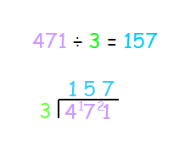
6) (Year 5) Short division HTO ÷ O

7) (Year 5) Short division ThHTO ÷ O

8) (Year 6) Short division ThHTO.t ÷ O
Display remainder as a fraction and a decimal.

9) (Year 6) Short division HTO ÷ TO
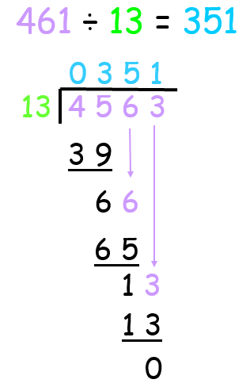
10) (Year 6) Long division HTO ÷ TO
(Use partitioning to count up)

